Criminal Law

Student's Name
Academic Institution
Date

Criminal Law
Criminal offenses refer to actions that are punishable under the law. Criminal laws deal with crime and the legal consequences that are associated with criminal offenses. Criminal law stipulates actions that are perceived as harmful, threatening, or endangering the safety, health of people, and property. It also entails legal punishment and rehabilitation of individuals that violate criminal law. Criminal laws from civil laws and varies depending on the jurisdiction. Unlike civil law that focuses on resolving disputes and compensating victims, criminal law emphasizes punishment and rehabilitation. For this assignment, I will focus on Sweden's criminal law and how it addresses criminal offenses, specifically sexual assault.
The existing legislation for sexual assault in Sweden is the Swedish Criminal Code which was adopted in 1962 and started being enforced in 1965. The criminal code contains provisions on acts that are determined to be criminal offenses in Sweden. The Swedish Criminal Code also has general provisions for all other crimes, the legal punishment for the crimes, and the law's applicability (Pradel, 2017). Sexual assault crimes committed are judged in conformity with Swedish law by the Swedish court. The specific language used to describe sexual assault includes attempts to commit rape, gross rape, sexual exploitation of minors, sexual coercion, the seduction of youth, procuring, gross procuring, sexual molestation, sexual intercourse with offspring, and gross sexual exploitation of a minor. Legal punishment for offenders who commit sexual assault ranges from 6 months to 10 years, depending on the act committed. There are exceptions made to the penal code when it involves minors, or there is little age difference and development between the person who is assaulted and that who committed the act. The law states that there shall be no public prosecution except if it is called for purposes of public interest (Pradel, 2017).

Sexual assault is sexual abuse that involves the use of coercion, exploitation, or violence. The victim does not give consent for sexual activity. Sexual assault affects all people; however, this criminal offense disproportionately affects women, girls, and children. Sexual assault is a major public health issue in Sweden. Women and children are vulnerable to assault compared to men. International Organizations such as the United Nations and the World Health Organization describe advocates against sexual assault. They consider sexual assault as a violation of human rights. The United Nations works to promote the right of women, girls, and children to live free of abuse and violence committed to them due to sexual assault. These organizations run programs that provide medical treatment and psychosocial assistance to victims and vulnerable populations.
The international community, made up of organizations and institutions such as the International Criminal Court, Interpol, and the International Court of Justice, play an important role in preventing these criminal offenses. The International Criminal Court (ICC) investigates, prosecutes, and adjudges people accused of committing crimes against humanity. Sexual violence, including rape, sexual slavery, and forced pregnancy, are classified as crimes against humanity. Interpol help to police its member countries which Sweden is part of. Interpol reinforces efforts to help law enforcement authorities and the international community in fighting crimes against humanity.
The judicial process for criminal offenses does not vary much between Sweden and Canada. Sexual assault is considered a criminal offense and treated as such. The Swedish Criminal Code criminalizes sexual assault with legislative amendments made on the law expanding its definition. Amendments that were passed into law in 2018 criminalize sex without consent, even when there is no coercion, threat, and violence (Nordborg& Niemi-Kiesiläinen, 2018). Individuals who are found to have committed sexual assault are prosecuted and imprisoned for a period ranging from 6 months to 10 years. The trial process entails activities such as sexual assault complaints, case recorded, an investigation by the police, prosecution of the suspect, and trial.
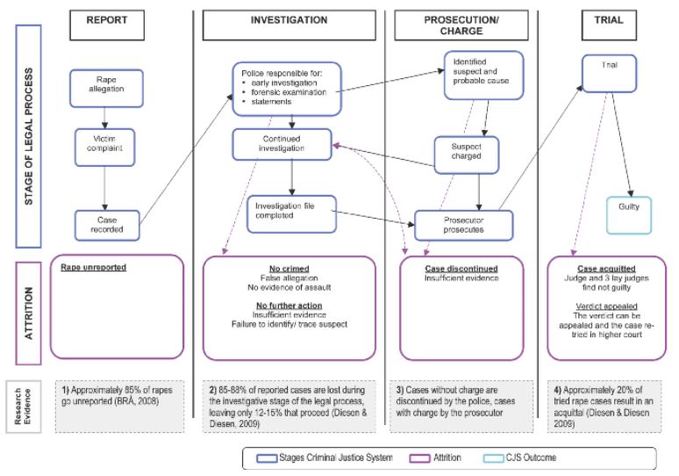
Map of the trial process of sexual assault cases in Sweden. Source (Lovett& Kelly, 2009)

In Canada, the trial process for sexual assault crimes is conducted the same as those who have committed crimes against humanity as they are conducted in the Criminal Penal Division of the Court of Quebec. In Canada, the trial process involves victims of sexual assault filing complaints with the police, police conducting investigations, transmitting the complaints to the penal prosecutor, and trial. Sexual assault in Canada is defined as an unwanted sexual act or sexual activity without consent; therefore, it is illegal, and perpetrators are liable for legal punishment and penalties.
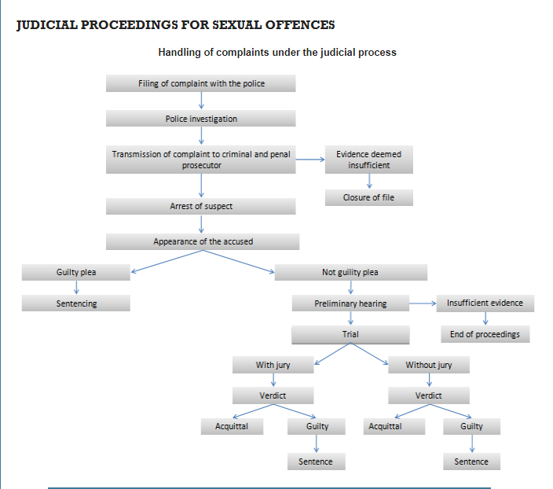
Judicial Proceeding of Sexual Assault Cases in Canada Source (INSPQ, 2021)
Canada is committed to working with partner organizations and donors to prevent, address and respond to sexual assault across the international community. In 2018, Canada, through its G7 presidency, negotiated for a declaration for the protection of individuals against sexual abuse and exploitation in international assistance. Additionally, Canada works with the United Nations in supporting programs that strengthen response to sexual abuse and exploitation. The country supports the United Nations' efforts to address sexual abuse and exploitation through the provision of financial support. Domestically, Canada has taken action to protect vulnerable populations against sexual assault by criminalizing it and prosecuting perpetrators of these crimes. Canada believes that sexual assault is a problem that requires concerted efforts; therefore has taken an innovative approach of directly involving men in projects that seek to end sexual abuse and exploitation against women and girls (Lam&Lepp,2019).

References
Judicial Process | INSPQ. INSPQ. (2021). https://www.inspq.qc.ca/en/sexual-assault/law/judicial-process.
Lam, E., &Lepp, A. (2019). Butterfly: Resisting the harms of anti-trafficking policies and fostering peer-based organising in Canada. Anti-trafficking review, (12), 91-107.
Lovett, J., & Kelly, L. (2009). Different systems, similar outcomes? Tracking attrition in reported rape cases across Europe. London: Child and Women Abuse Studies Unit, London Metropolitan University. Retrieved on February 11, 2010.
Nordborg, G., & Niemi-Kiesiläinen, J. (2018). Women's Peace:: A Criminal Law Reform in Sweden (pp. 353-373). Routledge.
Pradel, J. (2017). Applicability of Swedish Law.

